Assignment
In this lab, you will be investigating a SIM card image that the professor has provided. In order to view and investigate the image, you will be required to download and install the FTK Imager, which is located in the attached file
Once FTK Imager is installed, you will be required to answer the following:
- Provide a snapshot after mounting the SIM card image (5pts)
Answer:
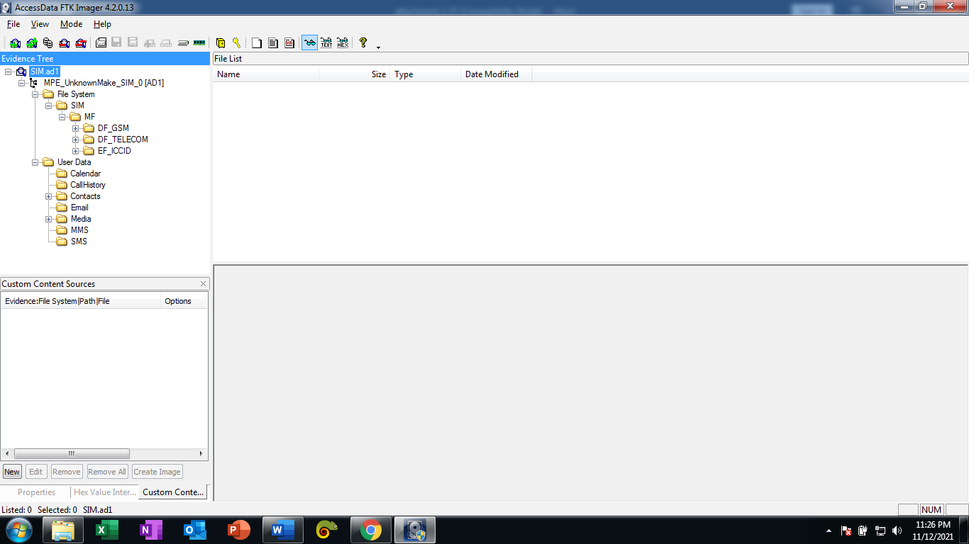

- What three subcategories do you see under master file? Explain what each of these categories are. (9pts)
Answer: First is the DF_GSM, second is the DF_TELCOM and the third one is the EF_ICCID
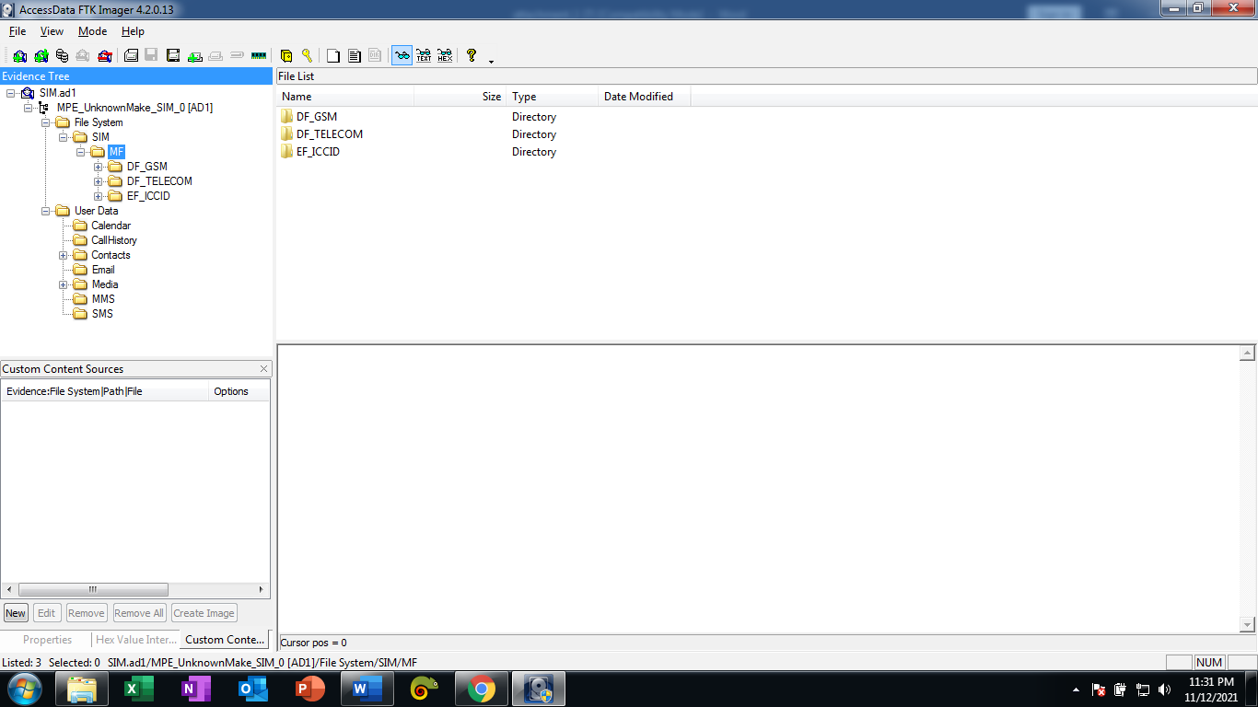

- What is the Integrated Circuit Card Identifier for this SIM card? What is the mobile country code for this ID number? (9pts)
Answer: The ICCD number is 89310170105114275884. The mobile country code is 310 or U.S. state of california
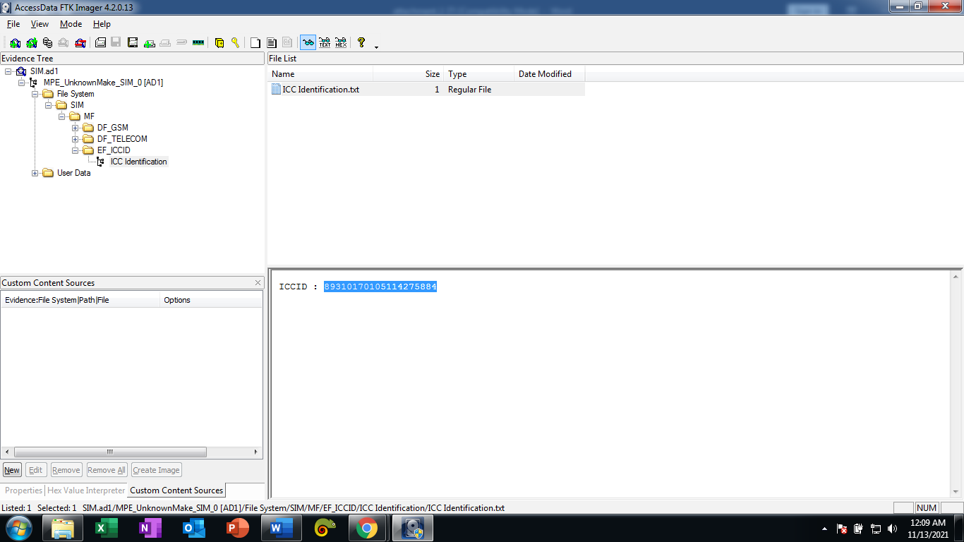

- What is the phone number for the tenth LND? (9pts)
Answer: The dialing number is 17602242168
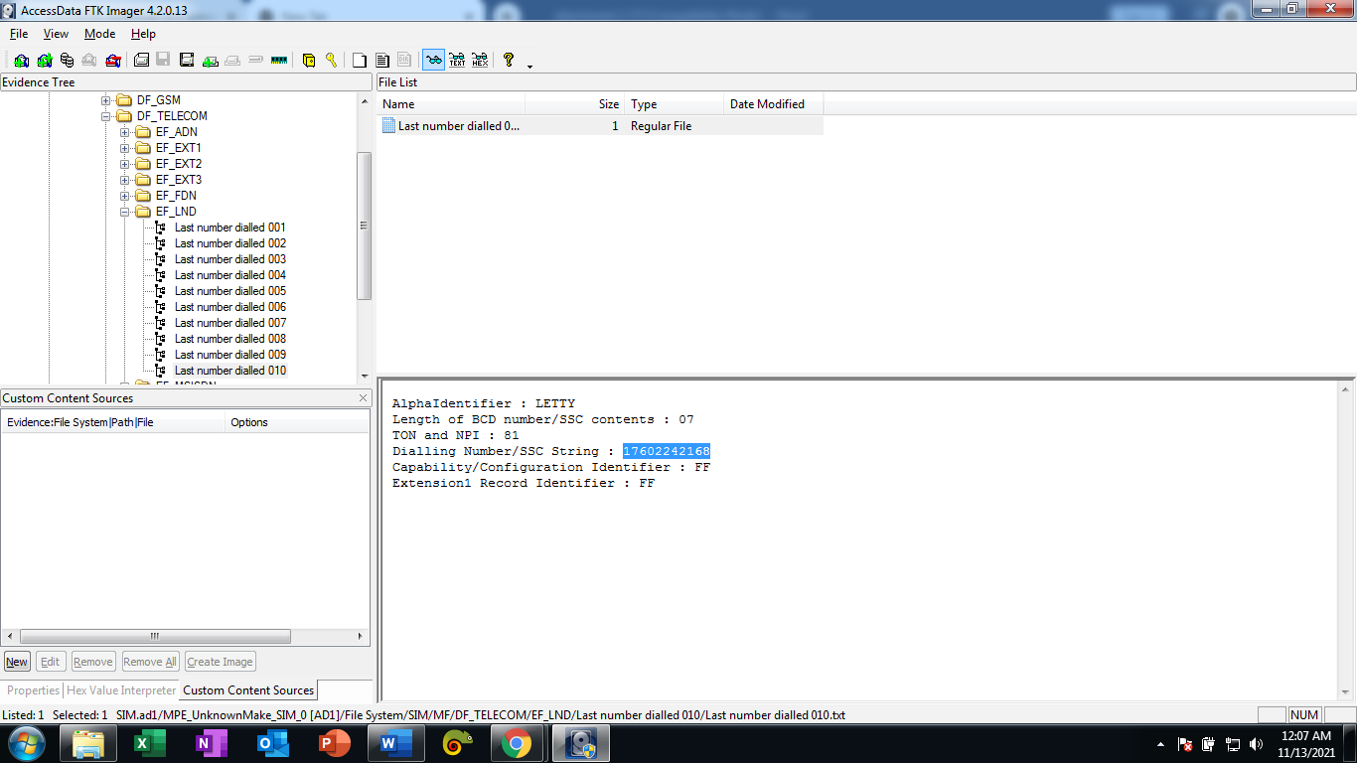

- What can you tell me about the image below? (9pts)
Answer: Base in the SIM mounted in FTK imager from SIM to MF to DF_TELCOM it is a short messages or what we called SMS and it’s Status is Unused.
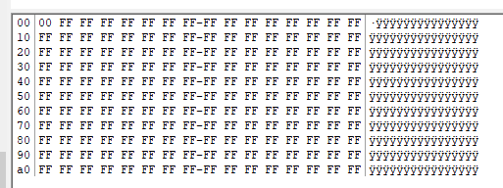

- What is the IMSI for the SIM card? Explain how you found it. Go to https://www.numberingplans.com/?page=analysis&sub=imsinr and provide of the information for the IMSI number you found for the SIM card. (9pts)
Answer: An ICCID (Integrated Circuit Card Identifier) is a globally unique classifier that can be used to identify SIM hardware (most prominently physical SIM cards). I found it by locating the IMSI file directory and open it
IMSI : 310170511427588
